QUIZ CLASH

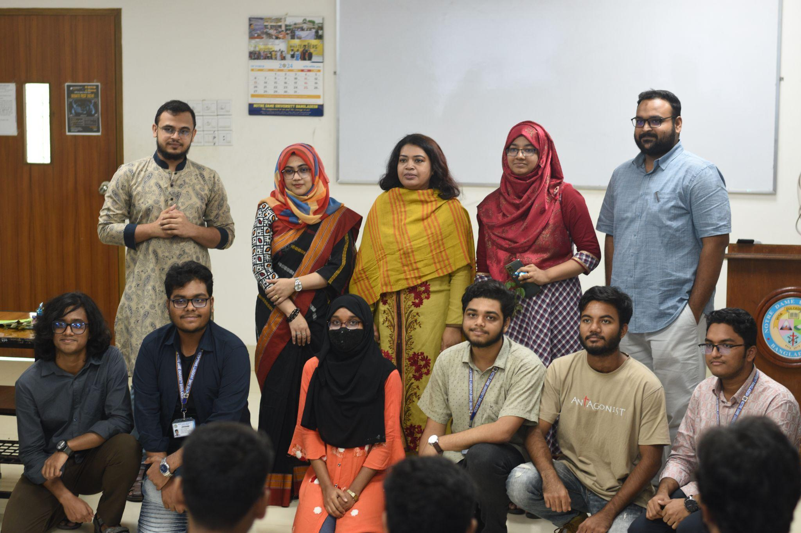
Participants with honourable faculties

The Freshers Welcoming Ceremony and Quiz Clash: Battle of Minds was conducted on October 22, 2024, by the Notre Dame University Computer Club (NDUBCC), marking the commencement of the new academic year and warmly welcoming the incoming students. This quiz competition featured participation from sections A and B of the CSE24 batch, aiming to encourage active engagement in future academic endeavours. The event not only introduced the freshers to the university's academic landscape but also promoted a culture of intellectual curiosity and friendly competition.

The ceremony commenced with a formal address by Prof. Dr. Shaheena Sultana, Chairperson of the Department of Computer Science & Engineering, who emphasised the importance of balancing academic pursuits with extracurricular involvement for a holistic educational experience. Faculty members greeted the freshers with enthusiasm, fostering an inviting and supportive environment. Additionally, prior to the competition, the incoming students were presented with tokens of appreciation from their senior peers, symbolising a spirit of camaraderie and mentorship within the university community.
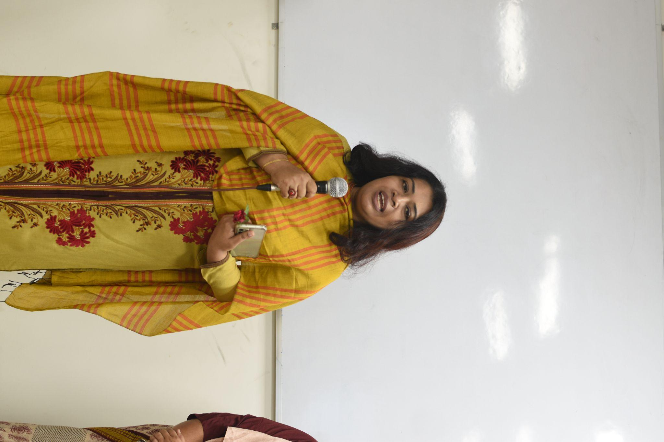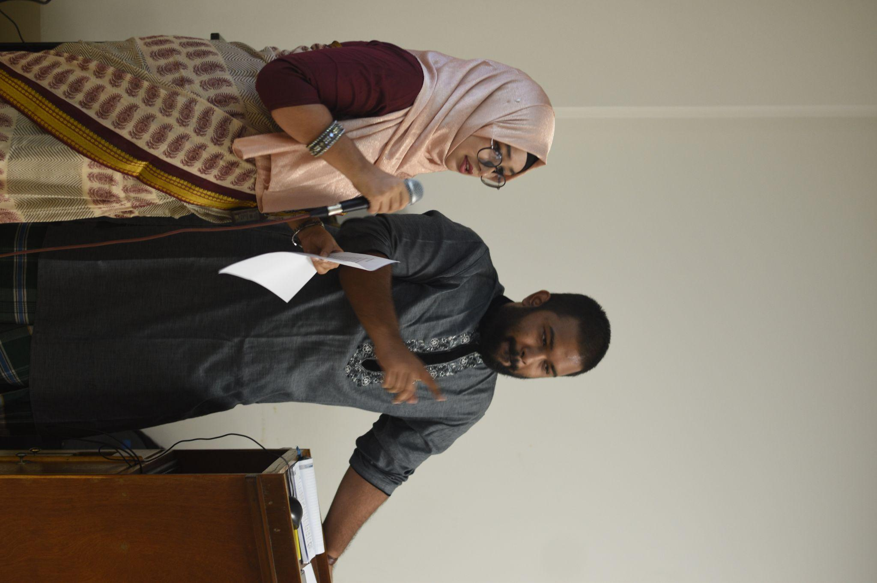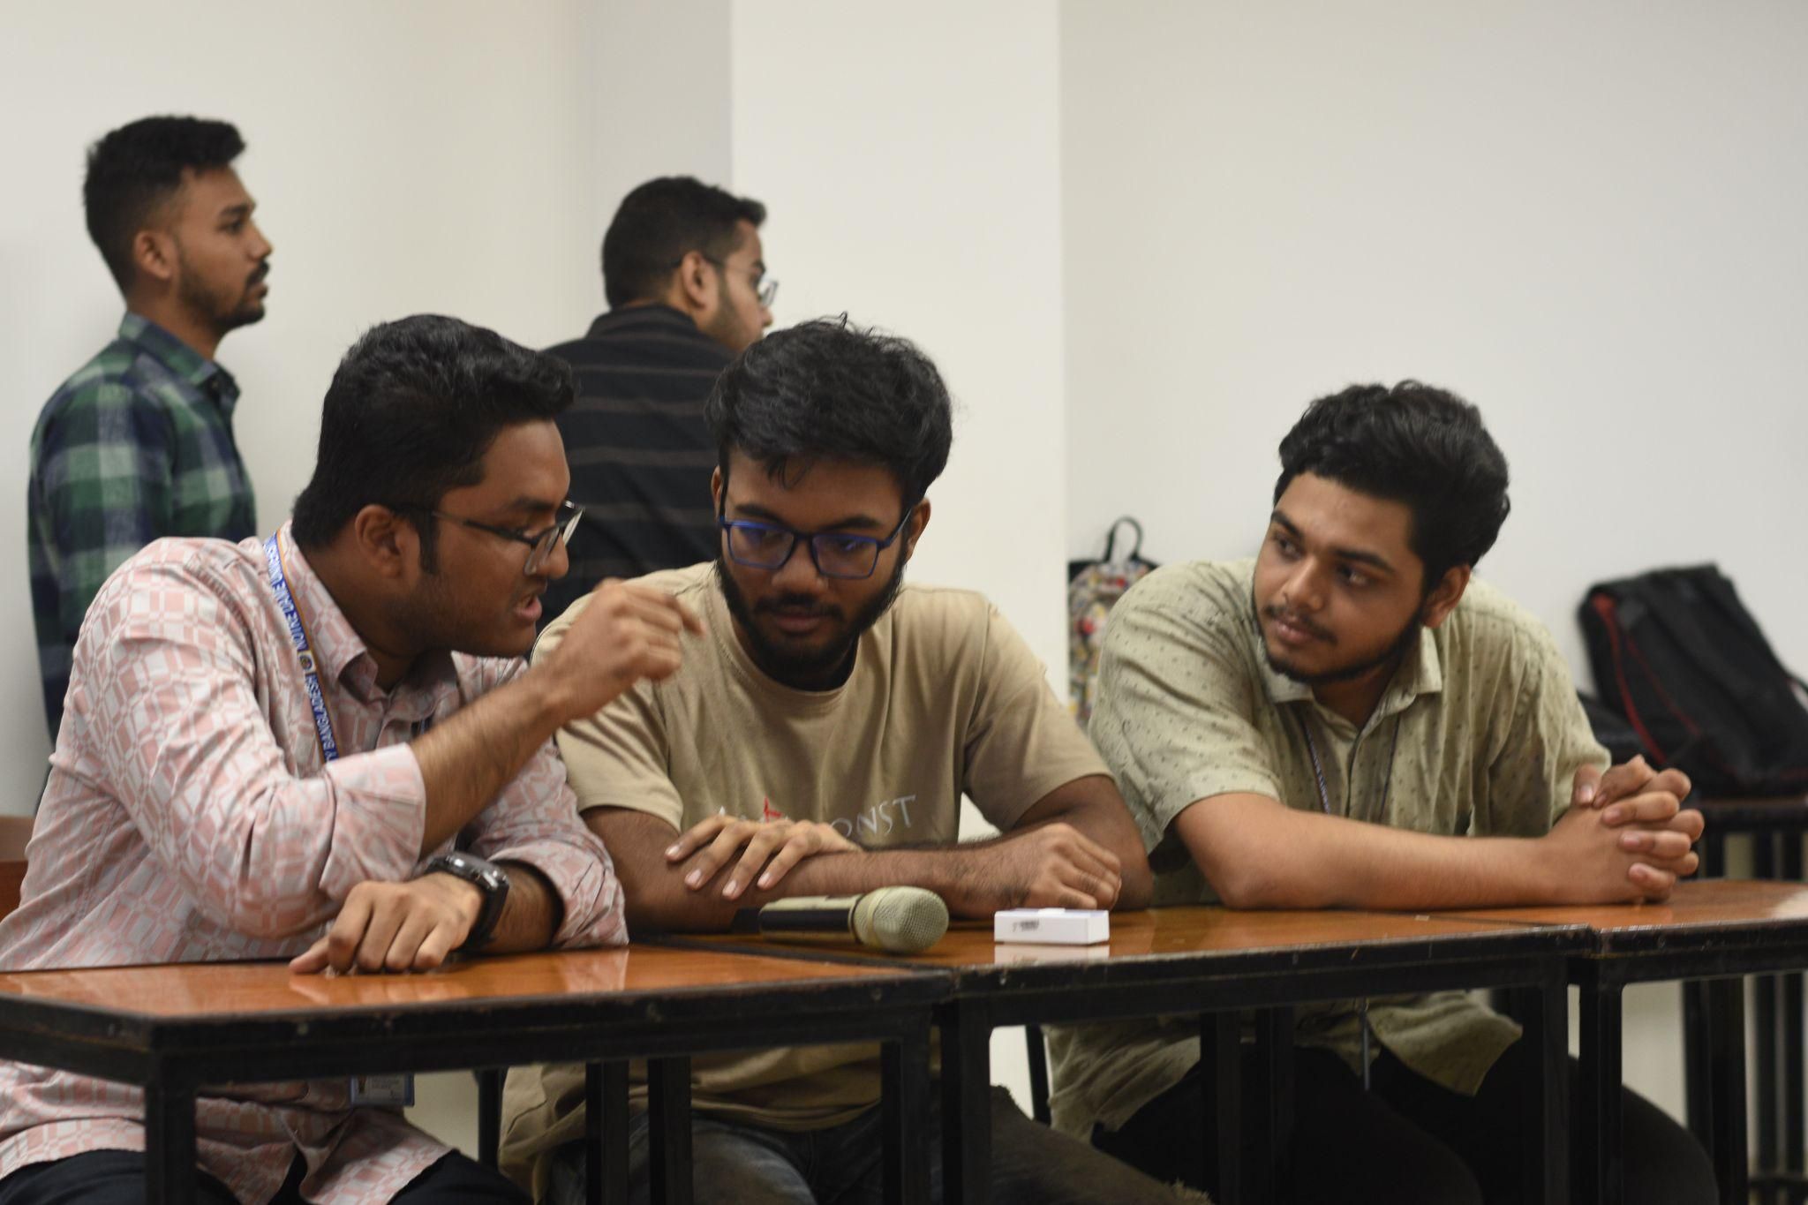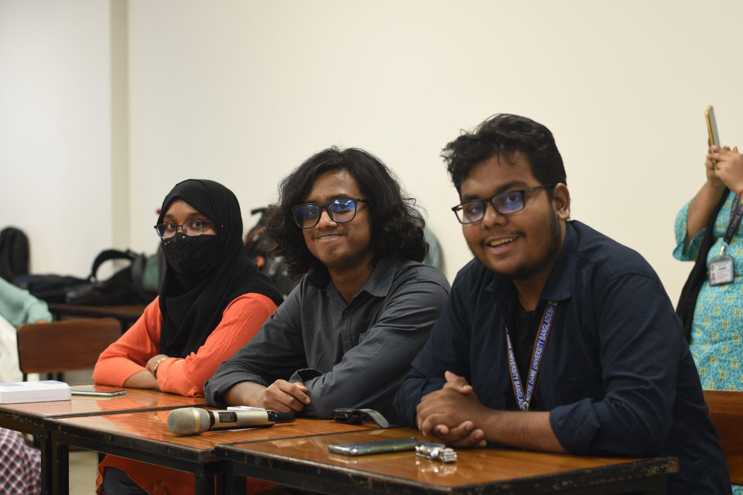
Moments from quiz clash

The Battle of Minds featured two teams from the CSE24 batch, each showcasing their knowledge and competitive spirit. Representing CSE 24 A was “Team Avengers”, comprised of Adison Mondol, Showmik Das Antu, and Ankon Goswami, who worked together to tackle the challenges of the quiz. From CSE 24 B, “Team BraveHearts” was made up of Farhana Nasir Snigdha, Talal Abid, and Prince Islam, all demonstrating teamwork and determination. Both teams brought their unique strengths to the competition, making for an exciting and closely fought contest.

The Battle of Minds consisted of three rounds, each bringing its own challenges. The Buzzer Round was the most exciting, testing both speed and knowledge, though incorrect answers led to point deductions. In the Segment Round, teams answered questions from various fields such as coding, sports, and entertainment. The final Googly Round featured a rapid-fire face-off between the top two teams. The competition began with a tough start for Team Avengers, who struggled in Round 1 and finished with 0 points, while Team BraveHearts took an early lead with 40 points. Avengers made a strong comeback in Round 2, scoring 30 points to BraveHearts' 20, but the gap remained. In the final round, Avengers added 10 more points, while BraveHearts held their lead, finishing with 60 points and securing the victory with a final score of 60-40.

The winning team will receive certificates, with a special award for the best individual fresher performance on November 12, 2024. Esteemed faculty members delivered inspiring speeches, encouraging students to join NDUBCC. The program concluded with insightful remarks from our esteemed alumni and CSE department lecturers, Nafisa Tabassum and Md. Tahmid Hasan.
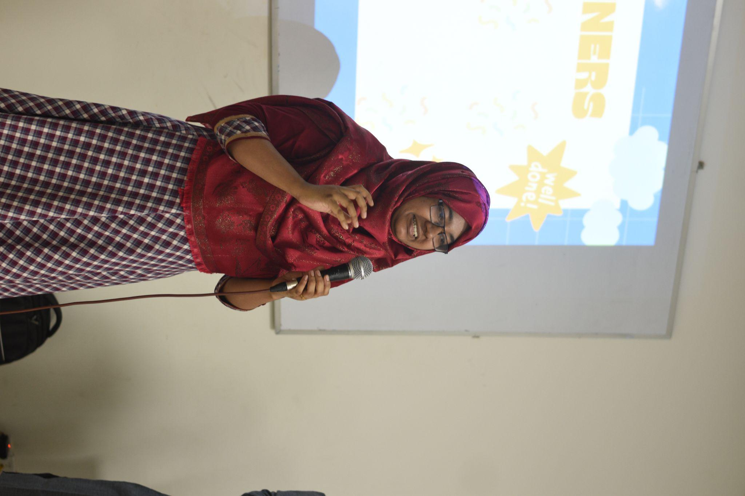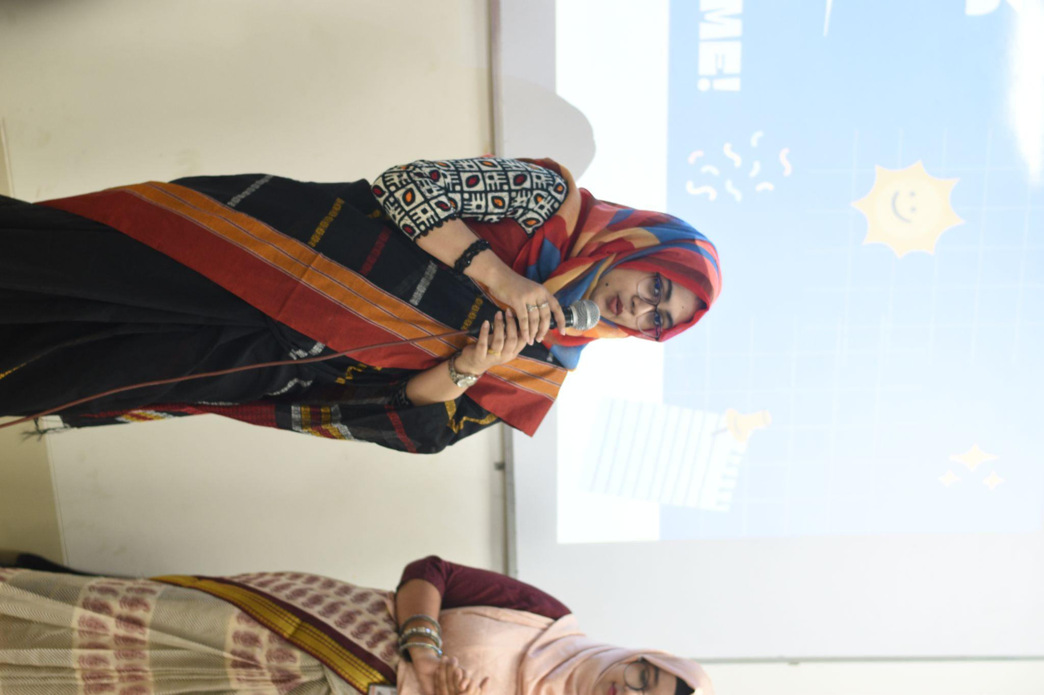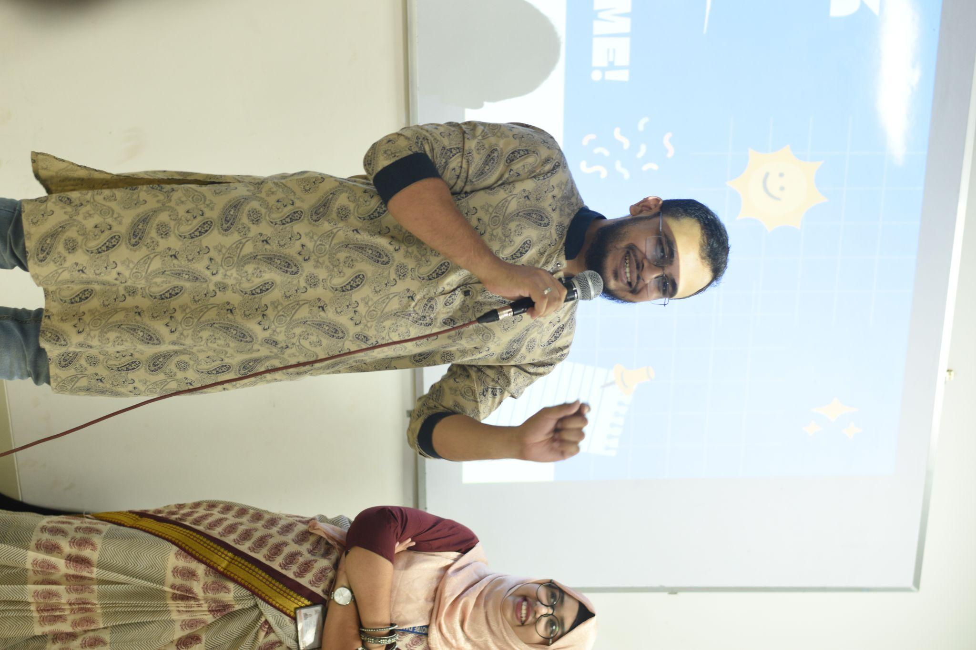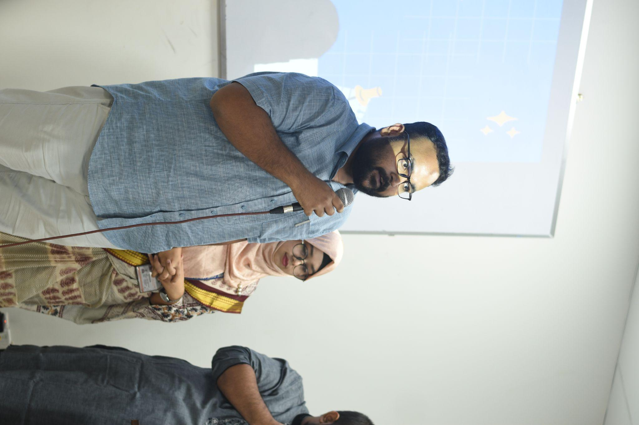
Appreciation from faculty members

The Freshers Welcoming Quiz Clash: Battle of Minds was a great success, offering a perfect blend of a warm welcome for new students and an exciting, knowledge-driven competition. The event created a unique space for freshers to connect with peers and seniors in a fun, intellectual environment.

The event highlighted the importance of academic and extracurricular involvement, setting a positive precedent for the academic year. Faculty support and peer interactions further enriched the experience, encouraging freshers to actively participate in university life. This initiative not only welcomed the newcomers but also inspired them to embrace the opportunities for growth that lie ahead. We anticipate the positive impact this event will have on their journey at Notre Dame University.

